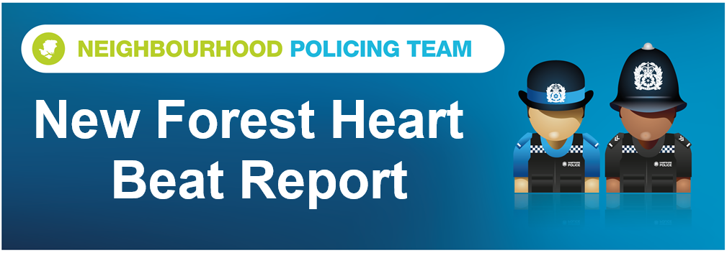

Hello and welcome to the October 2026 Beat Report for the New Forest Heart area. Your team is PC 24901 Mark ROBERTS, PC 27901 Stuart READHEAD and PCSO 14495 Richard WILLIAMS.
In November join us at one of our Beat Surgeries across the area – On Tuesday 3rd November at 11am we will be at the Happy Cheese Pub in Ashurst with the Ashurst and Colbury Neighbourhood watch team and then we will be on Brookley Road in Brockenhurst from midday.
On Wednesday 4th November at 11am we will be at the Lyndhurst Parish Council Office in the Community Centre in the village and on Monday 30th November join us at the Bramshaw Village Stores at 8am and then at the Bartley Post Office at 9am. Remember our Beat Surgeries last for 30 minutes or more if necessary.
This month’s Walking in Partnership Beat Surgery is at 11am on Saturday 14th November – BUT THE LOCATION IS YET TO BE DECIDED. As you can see from the list above we hold several Beat Surgeries every month and our Walking in Partnership events are another opportunity to ask us about Policing in your area, enjoy a guided walk in the New Forest, and receive the latest safety and crime prevention advice. For each walk we are joined by our colleagues at Forestry England and the National Park Authority and they explain what you can see at each location we visit. If you think this is something you would like to join us at one of these Beat Surgeries please email richard.williams@hampshire.police.uk and as soon as the venue is decided we will let you know
A house on the Sway Road in Brockenhurst was burgled between the 5th and 10th October and a large amount of property stolen. The house is close to the school so if you saw or heard anything suspicious during that time frame or have CCTV or Dashcam footage can you please contract us on 101 and quote the incident number 44260501843 – thank you
Another burglary happened at the Beau Chic hairdressers on the High Street in Lyndhurst. The crime number for that incident is 44260528095 and again if you have any information that might help us identify those who are responsible, please let us know.
Tack and farm machinery were also taken overnight from a farm on Deerleap lane.
Three vehicles were stolen in November – one was a moped from a driveway in Brook, one was a Quad bike from Bramshaw and the other was a car from a driveway in Bartley. Power cabling and other electrical items have been stolen from the building works taking place at Ashurst hospital, 150 rubber mats have been taken from Cadnams Pool car park and two electric bicycles have been stolen overnight from the car park of a block of flats in Brockenhurst. Money was also stolen from a fruit machine in a pub in Brockenhurst.
There have been four shopliftings in November, two at the Tesco in Brockenhurst, one at the petrol station also in the village and the other at Dobbies Garden Centre in Cadnam.
There have been ten thefts from motor vehicles with cars parked in the Knightwood Oak, on Cadnam Common and the Kings Hat car parks broken into while their owners were walking in the Forest. Tools were stolen from cars parked on driveways in Winsor and in the car park at the Travelodge at Stoney Cross and a catalytic converter was also stolen from the same car park but on a different night.
Golf clubs were taken from a car in Copythorne but were later recovered and returned to the owners, drone batteries were stolen from a car parked in a pub in Lyndhurst and two bass guitars were taken from the pub car park in Emery Down. Number plates were stolen from a car parked on Romsey Road in Copythorne and an attempt was also made to break into another vehicle, again overnight, in Cadnam.
Criminal damage has also been caused to gates in Ashurst and Lyndhurst and eggs have been thrown at houses in Lyndhurst.
Stay safe everyone
richard.williams@hampshire.police.uk
07554 775469

mark.roberts.2@hampshire.police.uk
07392 314340



