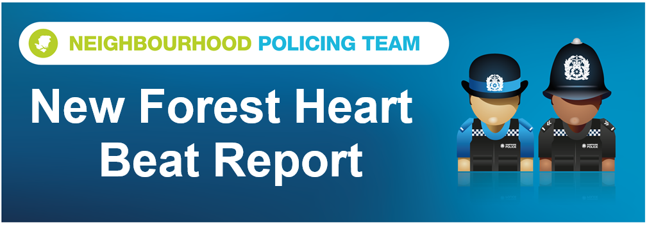

Hello and welcome to the April 2026 Beat Report for the New Forest Heart area. Your team is PC 24901 Mark ROBERTS, PC 27901 Stuart READHEAD and PCSO 14495 Richard WILLIAMS.
On Saturday 2nd May we will be joining our Sergeant 20401 Rob Blake for the MEET THE TEAM Beat Surgery in Totton. The team travels on bicycles through the town starting at Hangar Farm at 10am, then moving on to the West Totton Centre for 10.30 and finishing up at the Bartley Skate Park at 11am.
On Sunday the 3rd between 10am and 11.30 we will be back at the West Totton Centre for one of our security bike marking sessions. Bring your bike to us and we will security mark it for you and add it to the national Bike Register. The service is free thanks to New Forest District Council who have funded this initiative. Then on Monday 4th May we will be back outside the BOOST BIKE HUB in Brockenhurst for another bike marking session again between 10am and 11.30am.
On Monday 18th we will be at the Bramshaw village store at 8am and then at Bartley Post Office at 9am, on Tuesday 19th at 11am we will be at the Happy Cheese Pub in Ashurst with the Ashurst and Colbury Neighbourhood watch team and an hour later at midday on Brookley Road in Brockenhurst, just opposite Tesco. The following day, Wednesday 20th you can join us at the Lyndhurst Parish Council Offices at 11am.
Our Beat Surgeries last for 30 minutes, unless demand is high of course, but as we always say if you can’t come to any of these meetings you can always call or email us, but to report a crime or any anti-social behaviour dial 101 or go the Hampshire and IOW Police website. Of course if it’s an emergency always call 999.
We are also holding another one of our Walking in Partnership events on Wednesday 13th May at 6pm but haven’t chosen a venue yet. These events are for solo walkers or for people who don’t feel comfortable walking on their own in the New Forest and they are led by Forestry England. If you would like to be added to our mailing list so that we can let you know exactly when, where and what time these events take place please email richard.williams@hampshire.police.uk
21 year old Ryan Carpenter from Dorset has been charged with burglary other than a dwelling following a burglary and theft of a bike at the Boost Bike Hub on Station Approach in Brockenhurst. Carpenter was remanded in custody to next appear at Southampton Magistrates Court on Tuesday 12th May.
A considerable amount of damage was caused last month to the East Boldre Village hall. The hall is being fully refurbished but vandals have gone into the hall overnight and caused mindless damage and stolen some tools. Please if you have any information that you think will help us identify those responsible contact us and quote the crime number 44260176836.
Five sheds and outbuildings were broken into in April in Winsor, Bartley and Cadnam and the Bloor Homes building site on the outskirts of Totton was targeted twice. Copper piping was also stolen from a field in Bartley and a copper tank was taken from the garden of a house in Beaulieu.
Three vehicles were stolen in May from Beaulieu, Winsor and Cadnam and a pub in Brockenhurst had a group leave after drinking and eating without paying.
More damage has been caused to a car parked outside a house on the main A31 at Stoney Cross and Forestry England have reported that dozens of their new car parks signs have either been damaged or stolen. Again if you have seen anyone doing this at any of the Forest car parks let us know.
Other thefts in April included £300 worth of meat from Setley Ridge Vineyard and a suspect has been identified for that theft and we will update you next month on how that investigation is progressing.
A bath from a garden in East Boldre and the bolts from the wheel of a caravan at Matley Wood campsite were also stolen.
Easter is now behind us but the holiday season continues and that means that thieves will be targeting vehicles left unattended in the Forest and expensive bicycles. The message again this year is please take you valuables with you and don’t hide anything in the boot because you never know who is watching. And if you have a bicycle with you, if possible don’t leave it unattended but if you have to, use the best D lock you can find and again if possible remove something like a wheel or the saddle or both.
New Forest Heart Police are committed to reducing speed and animal deaths across the New Forest and Operation Mountie is where we team up with our partners at the New Forest Roads Awareness Team, Forestry England and the National Park Authority. Together we stop speeding drivers and as well as issuing tickets we talk to them about why the speed limit is 40 mph on Forest roads. This month we spent two hours at Hawkhill Inclosure on the road between Brockenhurst and Hatchet pond. Only four cars were stopped, two drivers were given tickets for speeds of 52mph and 59mph and all four were spoken to by our partners. As always thanks to the vast majority of drivers who stuck to the limit we really appreciate it – especially at the moment because the first of this year’s foals are being born AND the stallions will be out doing their thing soon which means the mare’s minds won’t be on road safety.
Stay safe everyone

richard.williams@hampshire.police.uk
07554 775469

mark.roberts.2@hampshire.police.uk
07392 314340



