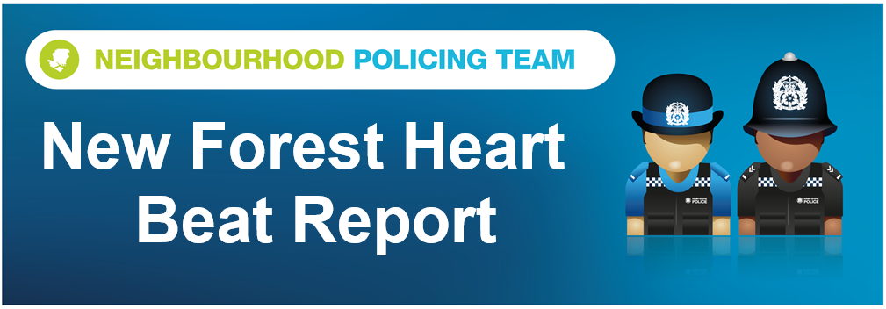
Hello and welcome to the June 2022 Beat Report for the New Forest Heart area. Your team in the North of the Forest is PC 25169 Carl PEVERILL and PCSO 14495 Richard WILLIAMS.
In July come and meet us at one of our Beat Surgeries and meetings across our area. On Saturday 2nd July from midday we will be at the Lyndhurst School fete and we will have a couple of our vehicles with us. Come and say hello, ask any questions you have and the young ones can have their photos taken in the cage in the back of the van.
On Saturday 9th July we are a holding a bike marking event in the main car park at Lyndhurst. Bring your bikes along and get them security marked so that if they do get stolen and we find them we can return them to you. We will be on site until 11.30.
Also in July we will be at the Post Office in the Happy Cheese at 11am on Tuesday 19th, and on Thursday 21st July we will be at the Bramshaw Stores at 8am, the Bartley Post Office at 10am and at the Open Door café in Minstead Church at 2pm.
At the end of the month the New Forest Heart team will be at the New Forest Show in Brockenhurst on all three days of the event so if you see us there do come and say hello.
High value bicycle thefts is again our main concern this month with 19 stolen from sheds, garages and outbuildings in Winsor, Lyndhurst, Brockenhurst, Brook and Ashurst and another 10 taken from campsites at Ashurst and Hollands Wood as well as the train station at Ashurst and at two hotel car parks in Brockenhurst. Please make your bicycles as secure as possible and when you take them out please don’t leave them unattended, an example of what can happen took place at 3.30pm on a busy afternoon outside the Community Centre in the main car park at Lyndhurst where a bike that had three locks on it was stolen while people were walking passed on their way to the village. Other outbuildings have been broken into at Emery Down, Lyndhurst, Beaulieu, Minstead and Fritham and power tools and garden machinery stolen.
The good news is that NO HOMES have been burgled on our Beat this month but the offices at the Woodlands Lodge Hotel in Woodlands and the Long Beech Campsite have been, and a safe and other items stolen. A motorhome on the Hollands Wood campsite just outside Brockenhurst was broken into while the owners were out and some expensive jewellery was taken and a hair salon in Brockenhurst was also broken into.
Vehicles that have been targeted this month include a van parked on a driveway in Winsor where tools were stolen, a car parked in the layby outside Copythorne School when a light box was stolen and someone has taken a water carrier and 2 propane gas cylinders from the front of a caravan on the Ocknell site. Cars were also broken into on Furzley Common and in the Rufus Stone car park.
Also in June number plates were removed from a car parked in Cadnam, a ride on lawn mower was taken from a garage port in Stoney Cross and a quad bike was stolen from Minstead.
Disappointingly we’ve had some damage caused to the play equipment in the Recreation Ground in Ashurst which means that some of the park has been closed until it can be repaired. If you know anything about this then please email Richard.williams@hampshire.police.uk
A couple of other things to mention this month include several sightings of a naked man seen walking in the New Forest. He’s been spotted in the area behind Boltons Bench, in the woods that run alongside the A35 between Ashurst and Lyndhurst and on the Lyndhurst golf course. He doesn’t appear to be a threat to the public but our advice is don’t approach him and contact us immediately.
We’ve also seen an increase in the number of cars and motorbikes using the Forest in an anti-social and dangerous way, and driving off road and doing stunts in car parks. We would encourage you to report any of this type of behaviour to us and if you have photographs and registration numbers then send them too –BUT DON’T PUT YOURSELF AT RISK BY COLLECTING THIS INFORMATION. With evidence we can issue Section 59 warnings to the drivers which means that if they are found continuing this behaviour their vehicles will be seized.
Finally OP MOUNTIE, our multi agency approach to reducing the speed of traffic across the New Forest and cutting animal deaths and accidents, continued in June. We held our first OP MOUNTIE on tour session at the beginning of the month and held sessions at two sites on Roger Penny Way but also at Pig Bush, Crockford Clump and Hawk Hill car parks. OP MOUNTIE uses a mix of enforcement from Police and education from our partners at Forestry England, the National Park Authority, the New Forest Roads Awareness Team, the Verders, Commoners, Agisters and New Forest District Council. It does seem that the excellent work they are doing is having an effect as unto the beginning of June there had been no animal deaths for 15 weeks. During this month’s session 3 speeding tickets were issued, 25 drivers were given educational advice and tickets were issued to drivers for having no MOT, no insurance and an illegal number plate. We also seized a car being driven by somewhere without a licence.
Remember if you need Police assistance in an emergency always call 999, to report a crime or incident of anti-social behaviour that has already happened call 101 or use the online reporting section of the Hampshire Police website. If you would like to contact the New Forest Heart Cops team directly with any questions or queries please use the details below

richard.williams@hampshire.pnn.police.uk
07554 775469

